Custom Fit – Tailor Your Ratings
General Feelings:
- I really enjoyed this session. We had good discussion amongst attendees and it was interesting to see how other shops used ratings.

Key Takeaways:
- There may be a difference in how we evaluate capacity vs how a DO evaluates capacity.
  - A PMA asset rating looks at how much the donor could give to ALL organizations. While a DO rating looks at how much could be given to the UO.
  - Some shops have capacity ratings (what they can donate to all orgs) as well as a solicitation level/suggested asks (what they can give to UO).
  - Some shops use a double rating – capacity and affinity (where affinity changes how much they are willing to give).
- Some shops store the actual capacity worksheet in the database and attach all necessary information to the prospect record.
  - Are we able to do this in Advance? Would this do away with the research reports folders and have everything centrally located in Advance?

Potential Ideas:
- Ask Kris Hunt (OSU) to see their capacity worksheet – OSU had a nice looking checklist that takes into account personal details (children, legal concerns, etc).
- Danielle and I talked about how it would be a good idea to create a mini capacity brochure for DOs (similar to the stage progression used by PM). This would give an explanation of all the different types of ratings.

It’s All About Location
General Feelings:
- This session was an introduction to looking at resources. The speaker had lots of resources to share but just read the slides verbatim. No discussion.

Key Takeaways:
- Look at the slides above – there are a lot of different topics.
- Resource List
- Profile of International Home Buying Activity
- Zillow – Research and Visuals (includes a most expensive houses search)

Parent Research
General Feelings:
- This session was not very helpful – focused less on what prospect research office can do and more on what DOs should be doing. Also, the things they implanted are much easier to do in their type of shop (small Catholic University).

Key Takeaways:
- Have Research Point screen parents. These should be a top priority compared to others (since parents are only prospects for a small amount of time compared to an alumnus).
  - We could have the student workers individually look up people and save us money?
- Have DOs attend IntroDUCKtion and send them a special questionnaire in order to receive info about their own education and profession.
  - Also have them ask for a gift on the very first visit
  - Don’t rule out grandparents – especially if the child is a legacy.
- Parents are more likely to make a gift that will benefit their kid who is currently in college rather than a future college kid.
- If you do not engage your parents from the start, you lose the window of opportunity (they are most likely only prospects for four years).

Guardian of the High Capacity Galaxy
General Feelings:
- This session was not very useful. They had just recently finished their campaign and talked about how it went down. Mostly just went over the logistic of the campaign (how much was raised, how many FTE) and tools they utilized. The tools were all variations of stuff we currently use.

Key Takeaways:
- Their school utilized a central intranet, almost like a wiki page. There was no folder system. Included links to the wiki page under the signature lines.
- They utilized Advance and on their home page, they included not just a scrolling list of assigned discovery prospects but a list of the discovery prospects who had not been contacted in a certain amount of time and a link to see the list.
- They also had their DOs fill out all research requests in Advance (similar to PM tasks).

Taking Care of Canadian Business
General Feelings:
- I felt like this presentation was interesting and applicable to our organization. There are over 91,000 grant making foundation in North America and a ton of potential.

Takeaways:
- Their school developed a rating system to evaluate Corporations and Foundations. The rating system they used is subjective… but we could make our own.
- GrantConnect is a good tool to find lists of grants in Canada. iWave is a useful tool for corporations.
- The farther away a company is from your school’s location, the harder it is to build a location. Stick to local organizations.
- Their Rating System: Overview, Foundations, Corporations

Integrating Corporate and Foundation Relationships into Prospect Management and Research
General Feelings:
- This presentation was somewhat helpful. Mostly talked about a survey of CFR shops and then talked about their institution.

Takeaways:
- Capacity ratings for organizations are different from individuals. Individuals are over 3-5 year period of time. Corporations/Foundations are more transactional and are over 12-18 months.
- Foundations:
  - When looking at fair market value of assets – track the past three years. Is it fluctuating? Growing? Declining?
  - Who is contributing money? A company, family, individual?
  - What are the distributions and expenditures? How much do they give away? How much do they spend on expenses?
  - What are the grants? Recipients and amounts?
  - What kinds of investments does the foundation have and are there multiyear grants?
- Corporations
  - 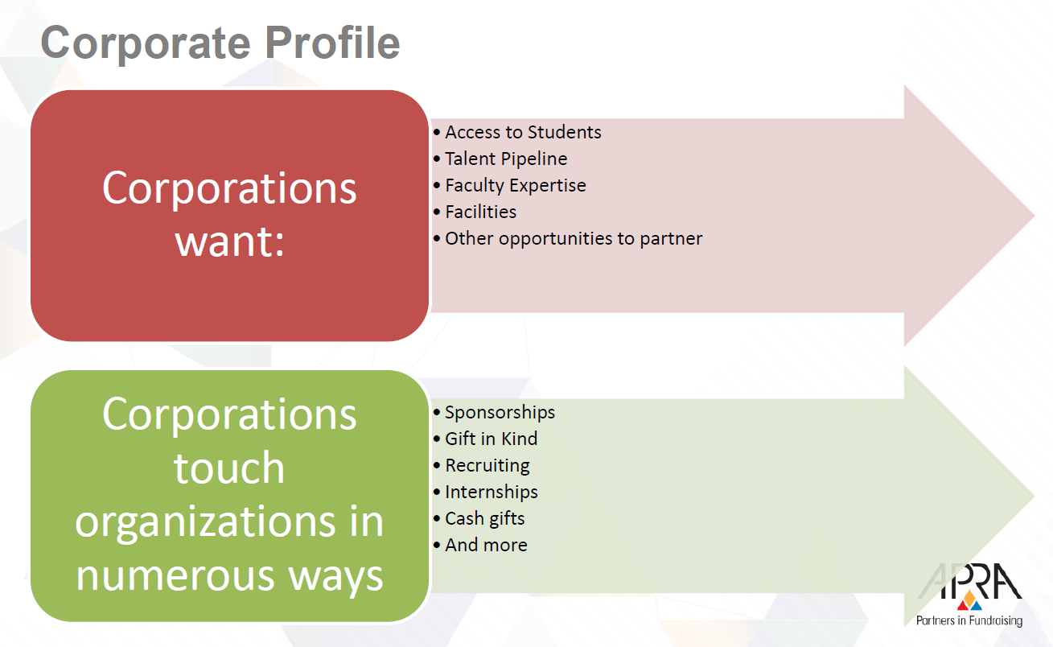

Philanthropy Coast to Coast
General Feelings:
- This session was mostly centered around Development Officers and less on prospect research. They talked a lot about what DOs can expect in visits and what to expect from traveling to different parts of the country. I wish it had focused less on DOs and more on what researchers can do to help.

Industry Corner: Law, Pharm. and Startups
General Feelings:
- This session was a great discussion with lots of info. The slides above have tons of information on salaries.
Takeaways:
- See slides for detailed information on salaries.
- General Counsels for large companies make a lot of money

